**1. Write a java program to demonstrate the working of Singly Linked List. // Program to implement Singly Linked List** package singlyLinkedList; import java.util.Scanner;

class Node {

int data; Node next;

public Node(int data) {

this.data = data;

this.next = null;

}

}

public class SinglyLinkedList {

// defining the head and tail of a singly linked list

Node head; Node tail;

public SinglyLinkedList() {

head = null;

tail = null;

}

public boolean isEmpty() {

return (head == null);

}

// function to add a node to the list public void insert(int data) {

Node newNode = new Node(data); // if(isEmpty()){} if (head == null) {

head = newNode; tail = newNode; } else { tail.next = newNode;

tail = newNode;

}

}

// function to add a node at head public void insertAtHead(int data) {

Node newNode = new Node(data); if (head == null) { head = newNode; tail = newNode; } else { newNode.next = head;

head = newNode;

}

}

// function to add a node at tail

public void insertAtTail(int data) {

Node newNode = new Node(data);

if (head == null) {

head = newNode; tail = newNode; } else { tail.next = newNode; tail = newNode;

}

}

// insert node at head or tail or between head and tail

public void insertAtPosition(int pos, int data) {

Node newNode = new Node(data); int totalNodes = countNodes(); Node prev = null, current = head; // insert at head if (pos == 1) { // if list is empty if (head == null) {

head = newNode;

tail = newNode;

}

else {

newNode.next = head;

head = newNode;

}

}

// Insert at position

else if (pos > 1 && pos <= totalNodes + 1) {

// insert node at tail if (pos == totalNodes + 1) {

tail.next = newNode;

tail = newNode;

}

// Insert node between head and tail

else {

for (int i = 1; i < pos; i++) { prev = current;

current = current.next;

}

newNode.next = current;

prev.next = newNode;

}

} else {

System.out.println("Invalid node position!");

}

}

// delete node at head public void deleteAtHead() { if (head == null) {

System.out.println("Singly linked list is empty!");

} else if (head == tail){

// If there's only one node in the list, head and tail both become null

head = tail = null;

} else {

// More than one node

// Otherwise, move the head pointer to the next node

Node temp = head; head = head.next;

temp = null;

}

}

// delete node at tail public void deleteAtTail() { if (head == null) {

System.out.println("Singly linked list is empty!");

} else if (head == tail) {

// If there's only one node in the list, head and tail both become null

head = tail = null; } else {

// More than one node

Node current = head;

//Traversing upto second last node while (current.next != tail) {

current = current.next;

}

current.next = null; // Remove the last node

tail = current; // Update the tail to the second last node

}

}

// deleting node at head or tail or between head and tail public void deleteAtPosition(int pos) {

// if list is empty if(head == null) {

System.out.println("Singly linked list is empty");

}

// if head is to be deleted (deleting head node) else if (pos == 1) {

// single node case if(head==tail) {

// if there's only one node left head=null;

tail = null;

}

else {

// more than one node Node temp = head; head = head.next;

temp = null;

}

}

// deleting node at tail or between head and tail

else if(pos>1 && pos <=countNodes()) {

Node prev = null, current = head; for(int i=1;i<pos;i++) {

prev = current;

current = current.next;

}

//deleting last node if(current.next== null) { prev.next =null;

tail = prev;

}

// Delete specific node between head and tail

else {

prev.next = current.next;

}

}

else {

System.out.println("Invalid node position!");

}

}

// function to display the data in the list public void displayList() {

// Pointing the head to the node called current Node current = head; if(head == null) {

System.out.println("The given list is empty!");

return;

}

System.out.println("The data in the given list are: ");

while(current!=null) {

// Printing each data in the list and next pointer pointing to the next node System.out.print(current.data+" --> "); current = current.next;

}

System.out.print("Null");

System.out.println("\n");

}

//Function to count total nodes

public int countNodes() {

int count = 0;

// Node current will point to head

Node current = head; while(current!=null) {

//Increment the count by 1 for each node

count++;

current = current.next;

}

return count;

}

// Reverse the node of list and print it public void reverseList() {

Node curr = head, prev = null, temp; tail = curr;

// Checks if list is empty if(head==null) {

System.out.println("list is empty");

return;

}

// Traverse all the nodes of linked list while(curr != null) {

// Store next node in temp

temp = curr.next;

// Reverse current node's next pointer curr.next = prev;

// Move pointers one position ahead

prev = curr;

curr = temp;

}

head = prev; // set prev is head

}

// search key in linked list public void search(int key) {

Node current = head; int flag=0;

int pos = 1;

while(current!=null) {

if(current.data==key) {

System.out.println("The "+key+" is found at "+pos+" position!");

flag=1;

}

current=current.next; pos++;

}

if(flag==0) {

System.out.println(key+" not found!");

}

}

public static void main(String args[]) {

SinglyLinkedList sll = new SinglyLinkedList(); Scanner sc = new Scanner(System.in);

int data, pos;

int choice;

do {

System.out.println("1. Insert");

System.out.println("2. Insert At Head");

System.out.println("3. Insert At Tail");

System.out.println("4. Insert At Position");

System.out.println("5. Delete At Head");

System.out.println("6. Delete at Tail");

System.out.println("7. Delete At Position");

System.out.println("8. Reverse List");

System.out.println("9. Search for key");

System.out.println("10. Total nodes");

System.out.println("11. Display list");

System.out.println("12. Exit");

System.out.println("\nPlease Enter your choise: "); choice = sc.nextInt(); switch (choice) { case 1:

System.out.println("Enter data: "); data = sc.nextInt(); sll.insert(data); sll.displayList();

break; case 2:

System.out.println("\nInsert Node at head - Enter data: ");

data = sc.nextInt(); sll.insertAtHead(data);

sll.displayList(); break; case 3:

System.out.println("\nInsert Node at Tail - Enter data: "); data = sc.nextInt(); sll.insertAtTail(data);

sll.displayList();

break; case 4:

System.out.println("\nInsert Node at Position - Enter position: "); pos = sc.nextInt();

System.out.println("Enter the data: "); data = sc.nextInt();

sll.insertAtPosition(pos, data); System.out.println();

sll.displayList();

break; case 5:

System.out.println("\nDelete node at head: ");

sll.deleteAtHead();

sll.displayList();

break; case 6:

System.out.println("\nDelete node at tail: ");

sll.deleteAtTail();

sll.displayList();

break; case 7:

System.out.println("\nDelete node at position - Enter position: ");

pos = sc.nextInt(); sll.deleteAtPosition(pos);

sll.displayList();

break; case 8:

System.out.println("Reverse the SLL: "); sll.reverseList();

sll.displayList();

break; case 9:

System.out.println("Enter a key to search:");

int key = sc.nextInt();

sll.search(key);

break; case 10:

System.out.println("Total nodes in SLL: "+sll.countNodes());

break; case 11:

System.out.println("Print all nodes in SLL: "); sll.displayList(); break; case 12:

System.out.println("Exiting the program."); break; default:

System.out.println("You entered wrong choice!");

}

}while(choice!=12);

sc.close();

}

}

**Output:**

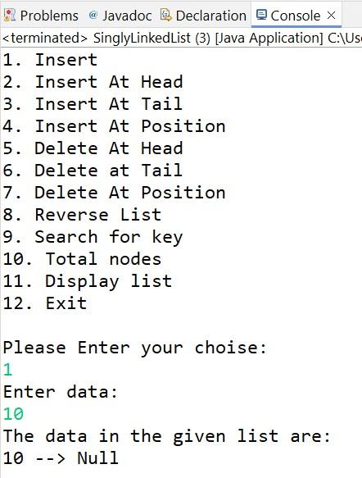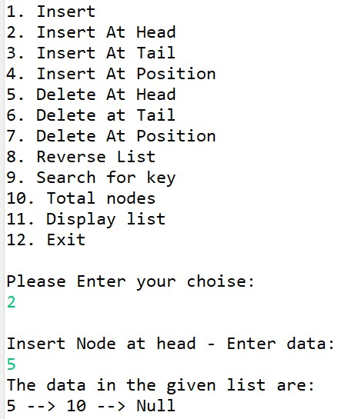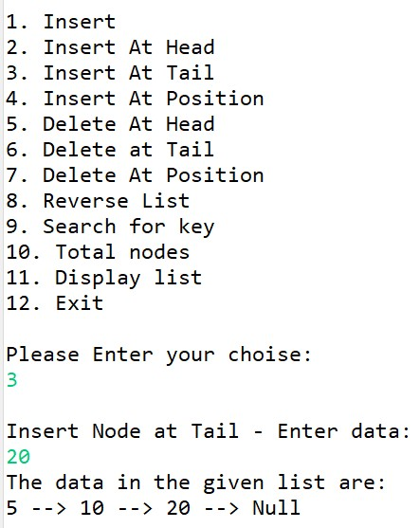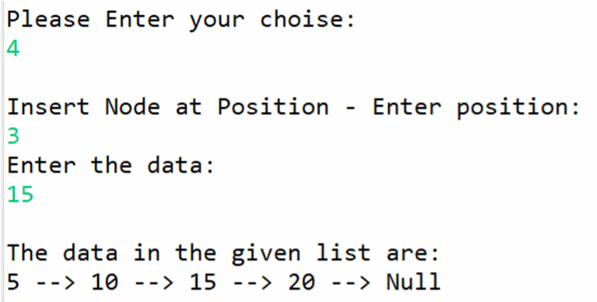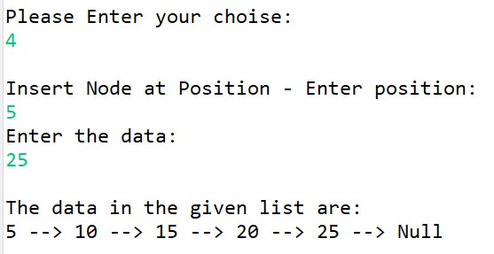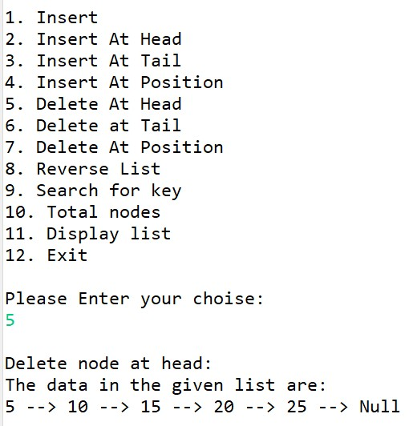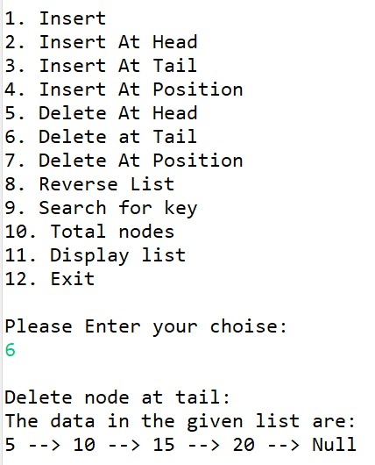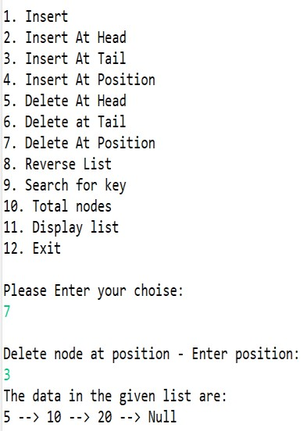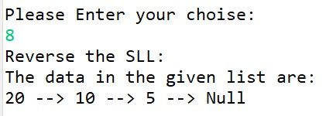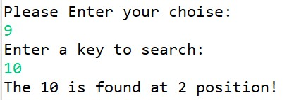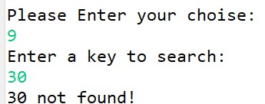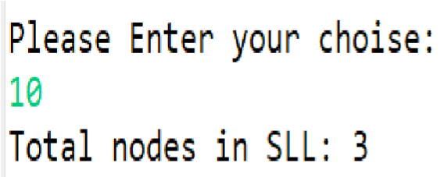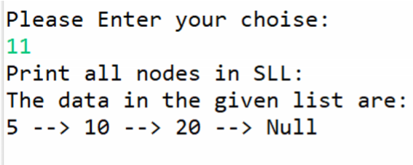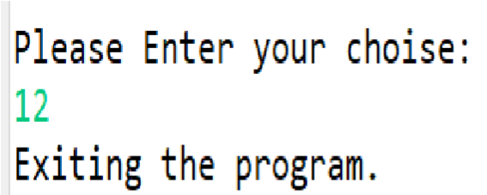

**2. Write a java program to demonstrate the working of Circular Linked List. // Program to implement Circular Linked List** package circularLinkedList; import java.util.Scanner;

class Node {

int data; Node next;

public Node(int data) {

this.data = data;

this.next = null;

}

}

public class CircularLinkedList {

// defining the head and tail of a singly linked list

Node head; Node tail;

public CircularLinkedList() {

head = null;

tail = null;

}

public boolean isEmpty() {

return (head == null);

}

// function to add a node to the list public void insert(int data) {

Node newNode = new Node(data); // if(isEmpty()){}

if (head == null) {

newNode.next = newNode; head = newNode; tail = newNode; } else { newNode.next = head; tail.next = newNode;

tail = newNode;

}

}

// function to add a node at head public void insertAtHead(int data) {

Node newNode = new Node(data); if (head == null) {

newNode.next = newNode;

head = newNode; tail = newNode;

} else {

newNode.next = head; head = newNode; tail.next = head;

}

}

// function to add a node at tail

public void insertAtTail(int data) {

Node newNode = new Node(data); if (head == null) {

newNode.next = newNode; head = newNode;

tail = newNode; } else { tail.next = newNode; tail = newNode;

tail.next = head;

}

}

// insert node between head and tail public void insertAtPosition(int pos, int data) {

Node newNode = new Node(data); int totalNodes = countNodes(); Node prev = null, current = head; // if list is empty

if (head == null) {

newNode.next = newNode; head = newNode;

tail = newNode;

}

// insert at head else if (pos == 1) {

tail.next = newNode; newNode.next = head;

head = newNode;

}

// Insert at position

else if (pos > 1 && pos <= totalNodes + 1) {

// insert node at tail if (pos == totalNodes + 1) {

tail.next = newNode; tail = newNode;

tail.next = head; // add

}

// Insert node between head and tail else {

for (int i = 1; i < pos; i++) {

prev = current;

current = current.next;

}

newNode.next = current; prev.next = newNode;

}

} else {

System.out.println("Invalid node position!");

}

}

// delete node at head public void deleteAtHead() { if (head == null) {

System.out.println("Circular linked list is empty!");

} else if (head == tail) {

// If there's only one node in the list, head and tail both become null

head = tail = null;

} else {

// Otherwise, move the head pointer to the next node

Node temp = head;

head = head.next; // move head to the next node

tail.next = head; // maintain the circular link

temp = null;

}

}

// delete node at tail public void deleteAtTail() { if (head == null) {

System.out.println("Circular linked list is empty!");

} else if (head == tail) {

// If there's only one node in the list, head and tail both become null

head = tail = null; } else {

// More than one node Node current = head;

while (current.next != tail) {

current = current.next;

}

// current.next = head; // Maintain the circular link

// tail = current; // Update the tail to the second last node

current.next = null; tail = current;

tail.next = head; // add

}

}

// deleting node between head and tail public void deleteAtPosition(int pos) {

// if list is empty

if (head == null) {

System.out.println("Circular linked list is empty");

}

// if head is to be deleted

else if (pos == 1) {

// single node case if (head == tail) {

// if there's only one node left

head = null;

tail = null;

} else {

// more than one node Node temp = head;

head = head.next;

tail.next = head; // Maintain the circular link

temp = null;

}

} else if (pos > 1 && pos <= countNodes()) {

Node prev = null, current = head;

for (int i = 1; i < pos; i++) {

prev = current;

current = current.next;

}

// deleting last node

if (current.next == head) { // change

prev.next = null;

tail = prev;

tail.next = head;// maintain the circular link

}

// Delete specific node between head and tail

else {

prev.next = current.next;

}

} else {

System.out.println("Invalid node position!");

}

}

// function to display the data in the list public void displayList() {

// Pointing the head to the node called current Node current = head; if (head == null) {

System.out.println("The circular list is empty!"); return;

}

System.out.println("The data in the given list are: "); while (true) { // change

// Printing each data in the list and next pointer pointing to the next node

System.out.print(current.data + " --> "); current = current.next; if (current == tail.next) {

break; // add

}

}

System.out.print("Null");

System.out.println();

}

// Function to count total nodes

public int countNodes() {

int count = 0; Node current = head; if (head == null) return count; // add

do { // change

// Increment the count by 1 for each node

current = current.next;

count++;

} while (current != head); // change

return count;

}

// search key in linked list public void search(int key) { if (head == null) {

System.out.println(key + " not found! The list is empty.");

}

Node current = head; int flag = 0; int pos = 1;

do {

if (current.data == key) {

System.out.println("The " + key + " is found at " + pos + " position!"); flag = 1;

}

current = current.next;

pos++;

} while (current != head);

if (flag == 0) {

System.out.println(key + " not found!");

}

}

public static void main(String args[]) {

CircularLinkedList cll = new CircularLinkedList();

Scanner sc = new Scanner(System.in);

int data, pos; int choice; do {

System.out.println("\n1. Insert");

System.out.println("2. Insert At Head");

System.out.println("3. Insert At Tail");

System.out.println("4. Insert At Position");

System.out.println("5. Delete At Head");

System.out.println("6. Delete at Tail");

System.out.println("7. Delete At Position");

System.out.println("8. Search for key");

System.out.println("9. Total nodes");

System.out.println("10. Display list");

System.out.println("11. Exit");

System.out.println("\nPlease Enter your choise: "); choice = sc.nextInt();

switch (choice) { case 1:

System.out.println("Enter data: "); data = sc.nextInt(); cll.insert(data); cll.displayList();

break; case 2:

System.out.println("Insert Node at head - Enter data: ");

data = sc.nextInt(); cll.insertAtHead(data);

cll.displayList();

break; case 3:

System.out.println("Insert Node at Tail - Enter data: ");

data = sc.nextInt(); cll.insertAtTail(data);

cll.displayList();

break; case 4:

System.out.println("Insert Node at Position - Enter position: ");

pos = sc.nextInt();

System.out.println("Enter the data: "); data = sc.nextInt();

cll.insertAtPosition(pos, data); System.out.println(); cll.displayList(); break; case 5:

System.out.println("Delete node at head: "); cll.deleteAtHead();

cll.displayList();

break; case 6:

System.out.println("Delete node at tail: "); cll.deleteAtTail(); cll.displayList();

break;

case 7:

System.out.println("Delete node at position - Enter position: ");

pos = sc.nextInt(); cll.deleteAtPosition(pos);

cll.displayList();

break;

case 8:

System.out.println("Enter a key to search:");

int key = sc.nextInt();

cll.search(key);

break; case 9:

System.out.println("Total nodes in SLL: " + cll.countNodes());

break; case 10:

System.out.println("Print all nodes in LL: ");

cll.displayList();

break; case 11:

System.out.println("Exiting the program.");

break; default:

System.out.println("You entered wrong choice!");

}

} while (choice != 11); sc.close();

}

}

|  |  |
| --- | --- |
|  |  |

**Output:**

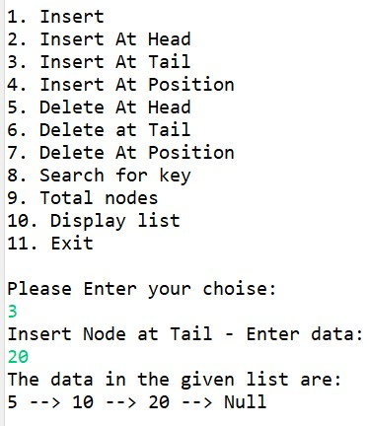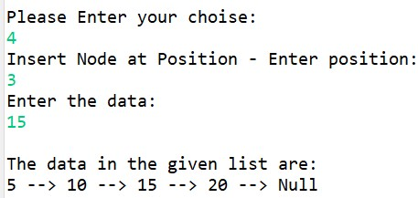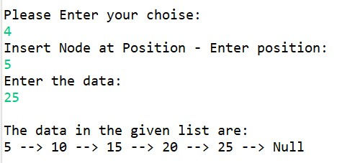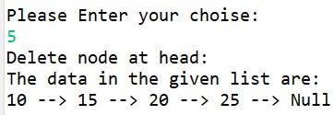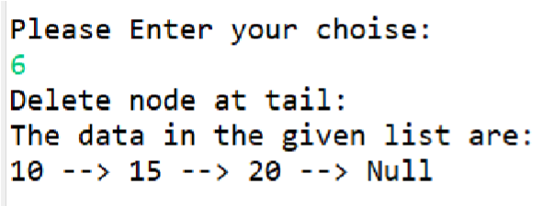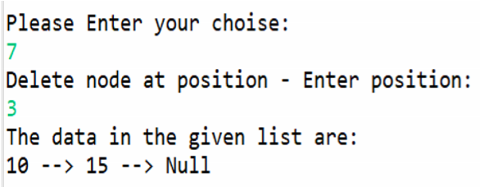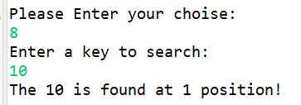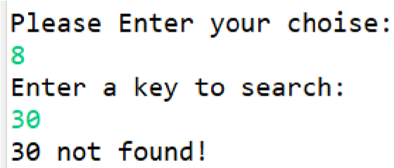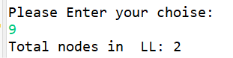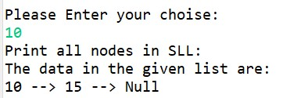

**3. Write a java program to demonstrate the working of Doubly Linked List.**

**Program:**

**// java program to implement Doubly linked list**

**// methods - displayList, isEmpty, insert, insertAtHead, insertAtTail**

**// insertAtPosition, deleteAtHead, deleteAtTail, deleteAtPosition**

**// countNodes, search** package doublyLinkedList; import java.util.Scanner; class Node {

int data; Node prev; // add Node next;

public Node(int data) {

this.data = data; this.prev = null; // add

this.next = null;

}

}

public class DoublyLinkedList {

// defining the head and tail of a singly linked list

Node head;

Node tail;

public DoublyLinkedList() { head = null;

tail = null;

}

public boolean isEmpty() {

return (head == null);

}

// function to add a node to the list

public void insert(int data) {

Node newNode = new Node(data); // if(isEmpty()){} if (head == null) {

head = newNode; tail = newNode; } else { tail.next = newNode;

newNode.prev = tail; // add

tail = newNode;

}

}

// function to add a node at head public void insertAtHead(int data) {

Node newNode = new Node(data); if (head == null) {

head = newNode; tail = newNode; } else { newNode.next = head;

head.prev = newNode; // add head = newNode;

}

}

// function to add a node at tail public void insertAtTail(int data) {

Node newNode = new Node(data); if (head == null) {

head = newNode; tail = newNode; } else { tail.next = newNode; newNode.prev = tail;

tail = newNode;

}

}

// insert node between head and tail public void insertAtPosition(int pos, int data) {

Node newNode = new Node(data);

// if list is empty

if (head == null) {

head = newNode;

tail = newNode;

}

// insert at head

else if (pos == 1) {

newNode.next = head; head.prev = newNode; head = newNode;

}

// Insert at position

else {

// if (pos > 1 && pos <= totalNodes + 1) remove this condition from else

Node current = head;

int currPos = 1;

while (current != null && currPos < pos) {

current = current.next;

currPos++;

}

if (pos < 1 || pos > currPos) {

System.out.println("Invalid node position!");

return;

}

// insert node at tail if (current == null) {

if (tail == null) {

head = newNode; tail = newNode; } else {

tail.next = newNode; newNode.prev = tail;

tail = newNode;

}

} // insert at middle

else {

newNode.next = current; newNode.prev = current.prev; current.prev.next = newNode;

current.prev = newNode;

}

}

}

// delete node at ead public void deleteAtHead() { if (head == null) {

System.out.println("doubly linked list is empty!");

} else if (head == tail) {

head = tail = null;

}

// If there's only one node in the list, head and tail both become null else {

// Otherwise, move the head pointer to the next node Node temp = head;

head = head.next; // move head to the next node

head.prev = null; // maintain the circular link temp = null;

}

}

// delete node at tail public void deleteAtTail() { if (head == null) {

System.out.println("doubly linked list is empty!");

} else if (head == tail) {

// If there's only one node in the list, head and tail both become null

head = tail = null; } else { Node temp = tail; tail = tail.prev; tail.next = null;

temp.prev = null;

}

}

// deleting node at head or tail or between head and tail

public void deleteAtPosition(int pos) {

Node current = head; int totalNodes = countNodes(); // if list is empty if (head == null) {

System.out.println("Doubly linked list is empty");

}

// if head is to be deleted else if (pos == 1) {

// single node case if (head == tail) {

// if there's only one node left

head = null; tail = null; } else {

// more than one node Node temp = head; head = head.next; head.prev = null; // add

temp.next = null; // add

}

} else if (pos > 1 && pos <= totalNodes + 1) { // delete node between head and tail if (pos == totalNodes) { // if only one node if (head.next == null) { head = null;

tail = null;

}

// if one or more nodes else {

Node temp = tail;

tail = tail.prev;

tail.next = null;

temp.prev = null;

}

} else {

for (int i = 1; i < pos; i++) {

current = current.next;

}

current.prev.next = current.next; // add current.next.prev = current.prev; // add current.prev = null; // add current.next = null; // add

}

} else {

System.out.println("Invalid node position!");

}

}

// function to display the data in the list public void displayList() {

// Pointing the head to the node called current Node current = head; if (head == null) {

System.out.println("The given list is empty!");

return;

}

System.out.println("The data in the given list are: ");

while (current != null) { // change

// Printing each data in the list and next pointer pointing to the next node System.out.print(current.data + " --> "); current = current.next;

}

System.out.print("Null");

System.out.println();

}

// Function to count total nodes

public int countNodes() {

int count = 0; Node current = head; if (head == null)

return count; // add

while (current != null) { // change

// Increment the count by 1 for each node count++;

current = current.next;

} // change

return count;

}

// search key in linked list public void search(int key) {

Node current = head; int flag = 0; int pos = 1; while (current != null) { if (current.data == key) {

System.out.println("The " + key + " is found at " + pos + " position!");

flag = 1;

}

current = current.next;

pos++;

}

if (flag == 0) {

System.out.println(key + " not found!");

}

}

public static void main(String args[]) {

DoublyLinkedList dll = new DoublyLinkedList(); Scanner sc = new Scanner(System.in);

int data, pos;

int choice;

do {

System.out.println("1. Insert");

System.out.println("2. Insert At Head");

System.out.println("3. Insert At Tail");

System.out.println("4. Insert At Position");

System.out.println("5. Delete At Head");

System.out.println("6. Delete at Tail");

System.out.println("7. Delete At Position");

System.out.println("8. Search for key");

System.out.println("9. Total nodes");

System.out.println("10. Display list");

System.out.println("11. Exit");

System.out.println("\nPlease Enter your choise: "); choice = sc.nextInt();

switch (choice) { case 1:

System.out.println("Enter data: "); data = sc.nextInt(); dll.insert(data);

dll.displayList();

break; case 2:

System.out.println("Insert Node at head - Enter data: ");

data = sc.nextInt(); dll.insertAtHead(data); dll.displayList();

break; case 3:

System.out.println("Insert Node at Tail - Enter data: ");

data = sc.nextInt(); dll.insertAtTail(data);

dll.displayList();

break;

case 4:

System.out.println("Insert Node at Position - Enter position: ");

pos = sc.nextInt();

System.out.println("Enter the data: "); data = sc.nextInt(); dll.insertAtPosition(pos, data); System.out.println(); dll.displayList();

break; case 5:

System.out.println("Delete node at head: ");

dll.deleteAtHead();

dll.displayList();

break; case 6:

System.out.println("Delete node at tail: ");

dll.deleteAtTail();

dll.displayList();

break; case 7:

System.out.println("Delete node at position - Enter position: ");

pos = sc.nextInt(); dll.deleteAtPosition(pos);

dll.displayList();

break; case 8:

System.out.println("Enter a key to search:");

int key = sc.nextInt();

dll.search(key);

break; case 9:

System.out.println("Total nodes in DLL: " + dll.countNodes()); break; case 10:

System.out.println("Print all nodes in DLL: "); dll.displayList(); break; case 11:

System.out.println("Exiting the program.");

break;

default:

System.out.println("You entered wrong choice!");

}

} while (choice != 11); sc.close();

}

}

**Output:**

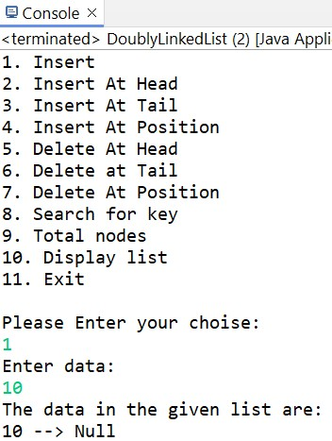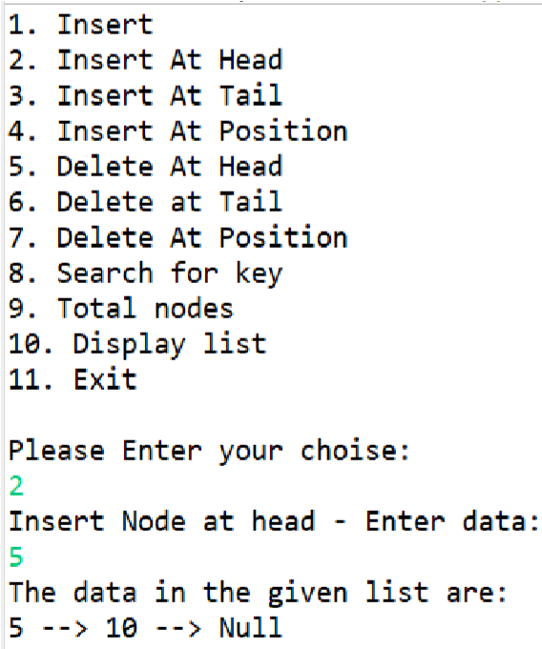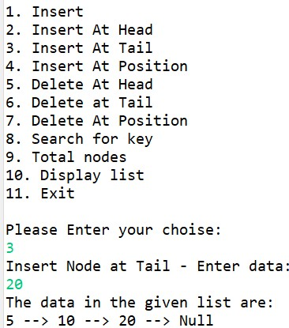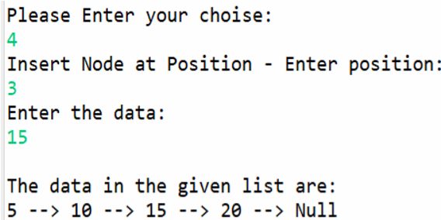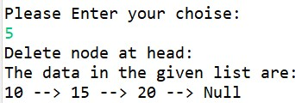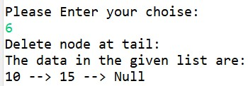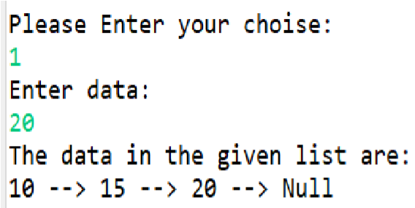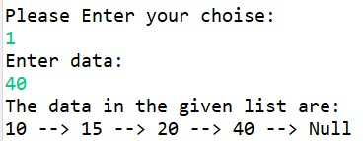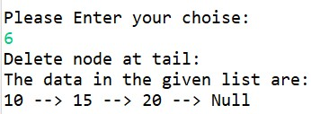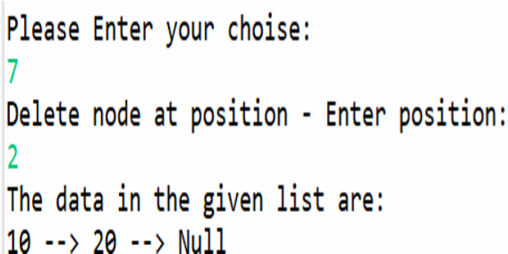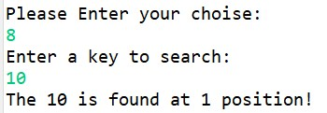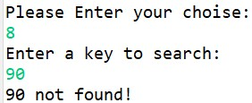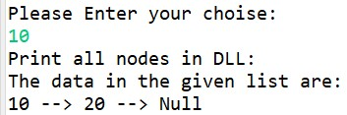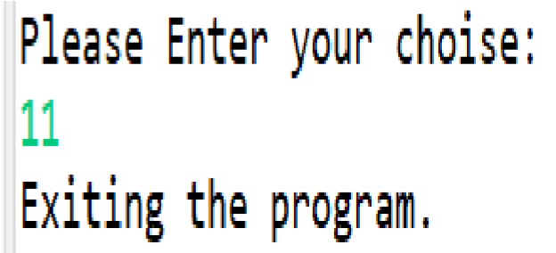

**4. Write a java program to perform addition of two polynomials using Linked List.**

**Program:**

// Addition of polynomial equations using linked list package poly;

class Node{

int coeff; int pow; Node next;

Node(int c, int p){

coeff=c;

pow=p;

next = null;

}

}

public class PolyAdd {

static Node addPolynomial(Node head1, Node head2) {

if(head1==null) {

return head2;

}

if(head2==null) {

return head1;

}

if(head1.pow>head2.pow) {

Node nextPtr = addPolynomial(head1.next, head2); head1.next = nextPtr;

return head1;

}

else if(head1.pow<head2.pow) {

Node nextPtr = addPolynomial(head1, head2.next); head2.next = nextPtr;

return head2;

}

Node nextPtr = addPolynomial(head1.next, head2.next);

head1.coeff= head1.coeff+head2.coeff; return head1;

}

static void printList(Node head) {

Node temp = head; while(temp!=null) {

System.out.print(temp.coeff+"x"+temp.pow+" --> "); temp = temp.next;

}

System.out.println("Null\n");

}

public static void main(String[] args) {

// first polynomial: 4x^3 + 3x^2 + 3x^0 Node head1 = new Node(4,3); head1.next = new Node(3,2); head1.next.next = new Node(3,0);

// second polynomial 2x^1 - 7x^0 Node head2 = new Node(2,1); head2.next = new Node(-7, 0);

Node head = addPolynomial(head1, head2);

System.out.println("The addition of two polynomial equation is : "); printList(head);

}

}

**Output:**

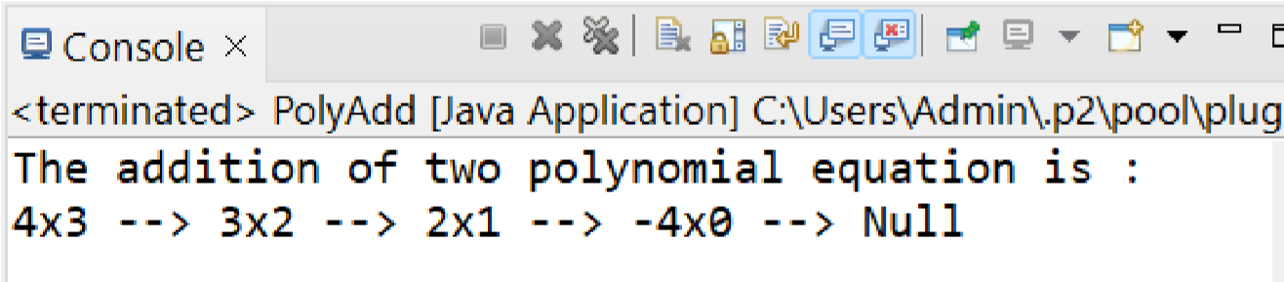

**5. Write a java program to demonstrate the working of Stack using Linked List.**

**Program:**

**// Java program to implement stack using singly linked list** package stack;

class Node{

int data; Node next; Node(int data){

this.data = data; this.next = null;

}

}

class Stack{

Node head; Stack(){ this.head = null;

}

Boolean isEmpty() {

return head==null;

}

void push(int d) {

Node newNode = new Node(d); if(newNode == null) {

System.out.println("Stack overflow! (insufficient memory)");

}

newNode.next = head;

head = newNode;

}

void pop() {

if(isEmpty()){

System.out.println("Stack Underflow! (is empty!)");

return;

}

else {

Node temp = head;

head = head.next;

temp = null; // for memory deallocation

}

}

int peek() {

if(isEmpty()) {

System.out.println("Stack Underflow! (is empty)"); return Integer.MIN_VALUE;

// return -1; // or you can write this also

}

else {

return head.data;

}

}

public void displayStack() {

Node current = head; if(head==null) {

System.out.println("Stack is empty!");

return;

}

System.out.println("The data in stack: "); while(current!=null) {

System.out.print(current.data+ " -> ");

current = current.next;

}

System.out.print("null\n");

}

}

public class StackSLL {

public static void main(String[] args) {

Stack st = new Stack(); st.push(10); st.push(20); st.push(30); st.push(40); st.push(50); st.displayStack();

System.out.println("The topmost element is "+st.peek()); st.pop(); st.pop(); st.displayStack();

System.out.println("The topmost element is "+st.peek());

}

}

**Output:**

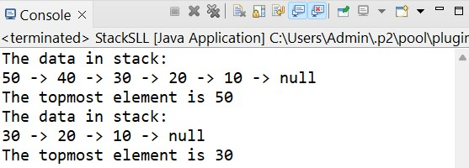

**6. Write a java program to demonstrate the working of Queue using Linked List.**

//Java program to implement queue data structure using linked list

package queue;

class Node{

int data; Node next;

Node(int data){

this.data = data; this.next = null;

}

}

class Queue{ Node front, rear;

Queue(){ front = rear = null;

}

boolean isEmpty() {

return front==null && rear == null;

}

// Function to add an element in the queue void enqueue(int d) {

// create a new linked list node Node new_node = new Node(d); if(rear==null) { front = rear = new_node; return;

}

rear.next = new_node;

rear = new_node;

}

// function to remove element from the queue

void dequeue() { if(isEmpty()) {

System.out.println("Queue Underflow!");

return;

}

Node temp = front; front = front.next; if(front==null) {

rear=null;

}

}

int getFront() {

if(isEmpty()) {

System.out.println("Queue Underflow!");

return Integer.MIN_VALUE;

}

else {

return front.data;

}

}

int getRear() {

if(isEmpty()) {

System.out.println("Queue Underflow!");

return Integer.MIN_VALUE;

}

else {

return rear.data;

}

}

public void displayQueue() { Node current = front; if(front==null) {

System.out.println("Queue is empty!");

return;

}

System.out.println("The data in Queue: "); while(current!=null) {

System.out.print(current.data+ " -> ");

current = current.next;

}

System.out.print("null\n");

}

}

public class QueueSLL {

public static void main(String[] args) {

Queue q = new Queue();

q.enqueue(10);

q.enqueue(20);

q.enqueue(30);

q.enqueue(40);

q.enqueue(50);

q.displayQueue();

System.out.println("\nFront element is "+q.getFront()); System.out.println("Rear element is "+q.getRear());

q.dequeue();

q.dequeue();

System.out.println(); q.displayQueue();

System.out.println("\nFront element is "+q.getFront());

System.out.println("Rear element is "+q.getRear());

}

}

**Output:**

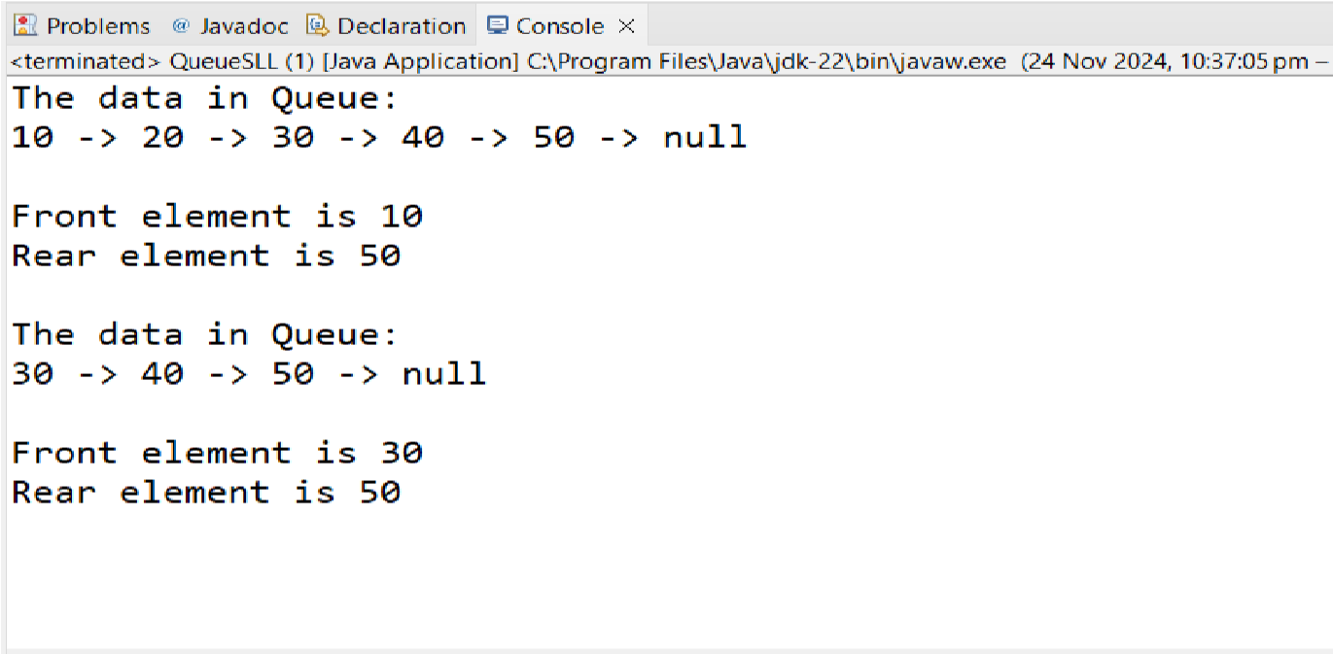

**7. Write a java program to demonstrate the working of Priority Queue using Linked List.**

// Java program to implement priority queue using linked list

package priorityQueue;

class Node{

int data;

int priority; // lower values indicate higher priority

Node next;

Node(int d, int p){

data = d; priority = p;

next = null;

}

}

public class PriorityQueue {

Node head;

public PriorityQueue() {

head = null;

}

public void add(int d, int p) {

Node start = head; Node newNode = new Node(d, p); if(head==null) {

head = newNode; return;

}

if(head.priority>p) {

newNode.next = head;

head = newNode;

}

else {

while(start.next != null && start.next.priority<p) { start = start.next;

}

newNode.next = start.next;

start.next = newNode;

}

}

public Node remove() {

Node temp = head;

head = head.next; temp = null;

return head;

}

int getHeadData() {

return head.data;

}

public boolean isEmpty() {

return head==null;

}

public void display() {

Node temp = head; System.out.println();

while(temp!=null) {

System.out.print("Data: "+temp.data+", priority: "+temp.priority+" --> ");

temp=temp.next;

}

System.out.println("Null");

}

public static void main(String[] args) {

PriorityQueue pq = new PriorityQueue();

pq.add(4,1); pq.add(5,2); pq.add(6,3); pq.add(7,0);

System.out.println("Head node data = "+pq.getHeadData());

pq.display();

//remove elements: pq.remove(); pq.remove();

pq.display();

System.out.println("\nHead node data after removing elements=

"+pq.getHeadData());

}

}

}

**Output:**

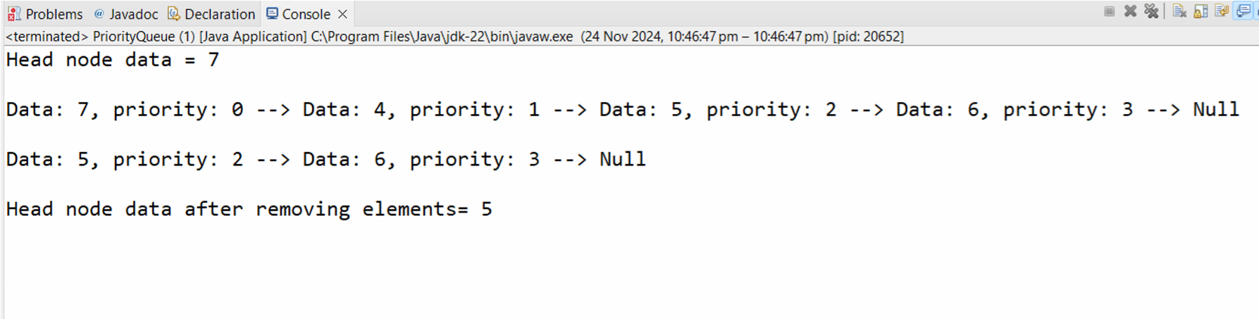

**8. Write a java program to demonstrate the working of Double Ended Queue using Linked List.**

package doubleEndedQueue;

import java.util.Scanner;

class Node{

int data; Node prev;

Node next;

// Function to get a new node public Node(int data) {

this.data = data; this.prev = null; this.next = null;

}

}

public class DoubleEndedQueue {

Node front; Node rear;

int Size;

public DoubleEndedQueue() {

front = rear = null;

Size = 0;

}

public boolean isEmpty() {

return (front==null);

}

// return the number of elements in the deque public int size() {

return Size;

}

// insert an element at the front end public void insertFront(int data) {

Node newNode = new Node(data); if(newNode==null) {

System.out.println("OverFlow!\n");

}

else {

// if deque is empty if(front == null) { //insert node at the front end

rear = front = newNode;

}

else {

newNode.next = front; front.prev = newNode;

front = newNode;

}

Size++; // to count element

}

}

// insert an element at the rear end public void insertRear(int data) {

Node newNode = new Node(data); if(newNode==null) {

System.out.println("Overflow!\n");

}

else {

// if deque is empty if(rear==null) { // insert node at the rear end

front = rear = newNode;

}

else {

newNode.prev = rear; rear.next = newNode;

rear = newNode;

}

Size++;

}

}

// delete the element from the front end public void deleteFront() {

// if deque is empty then underflow condition if(isEmpty()) {

System.out.println("Underflow - deque is empty");

}

//deletes the node form the front end

else {

Node temp = front; front = front.next;

// if only one element was present if(front ==null) {

rear=null;

}

else {

front.prev = null;

}

// decrements the count of elements by 1

Size--;

}

}

// delete the element from the rear end

void deleteRear() {

// if deque is empty then 'underflow' condition if(isEmpty()) {

System.out.println("Underflow - deque is empty!\n");

}

// deletes the node from the rear end

else {

Node temp = rear;

rear = rear.prev;

// if only one elements was present if(rear==null) {

front=null;

}

else {

rear.next = null;

}

//Decrements count of elements by 1

Size--;

}

}

// return the elements at the front end

public int getFront() {

// if deque is empty, then return -1 value

if(isEmpty()) {

return -1;

}

return front.data;

}

// return the elements at the rear end

public int getRear() {

// if deque is empty, then return -1 value

if(isEmpty()) {

return -1;

}

return rear.data;

}

public void display() {

Node current = front; if(front==null) {

System.out.println("The double ended queue is empty!");

return;

}

System.out.println("The data in double ended queue are: "); System.out.print("Null <- "); while(current!=null) {

System.out.print(current.data+" <-> ");

current = current.next;

}

System.out.print("Null");

System.out.println();

}

public static void main(String[] args) {

DoubleEndedQueue deq = new DoubleEndedQueue(); Scanner sc = new Scanner(System.in);

int data, pos;

int choice;

do {

System.out.println("1. Insert Front");

System.out.println("2. Insert Rear");

System.out.println("3. Delete Front");

System.out.println("4. Delete Rear");

System.out.println("5. Display");

System.out.println("6. Get Front");

System.out.println("7. Get Rear");

System.out.println("8. Exit");

System.out.println("\nPlease Enter your choise: ");

choice = sc.nextInt();

switch (choice) { case 1:

System.out.println("\n Insert Node at front - Enter data: "); data = sc.nextInt();

deq.insertFront(data);

deq.display();

break; case 2:

System.out.println("\n Insert Node at rear - Enter data: ");

data = sc.nextInt();

deq.insertRear(data); deq.display();

break; case 3:

System.out.println("\n Delete node at front: ");

deq.deleteFront();

deq.display();

break; case 4:

System.out.println("\n Delete node at Rear: ");

deq.deleteRear();

deq.display();

break; case 5:

System.out.println("\n Display Nodes: ");

deq.display();

break; case 6:

System.out.println("\n The front element is : "+deq.getFront());

break; case 7:

System.out.println("\n The front element is : "+deq.getRear());

break; case 8:

System.out.println("Exiting the program."); break; default:

System.out.println("You entered wrong choice!");

}

} while (choice != 8); sc.close();

}

}

**Output:**

